Copyright for test papers and marking guides remains with *West Australian Test Papers.*

Test papers may only be reproduced within the purchasing school according to the advertised Conditions of Sale.

Test papers should be withdrawn after use and stored securely in the school until Friday July 5th 2019.



**MATHEMATICS**

**SPECIALIST**

**UNIT 1**

**Semester One**

**2019**

**SOLUTIONS**

***Calculator−free Solutions***

1.

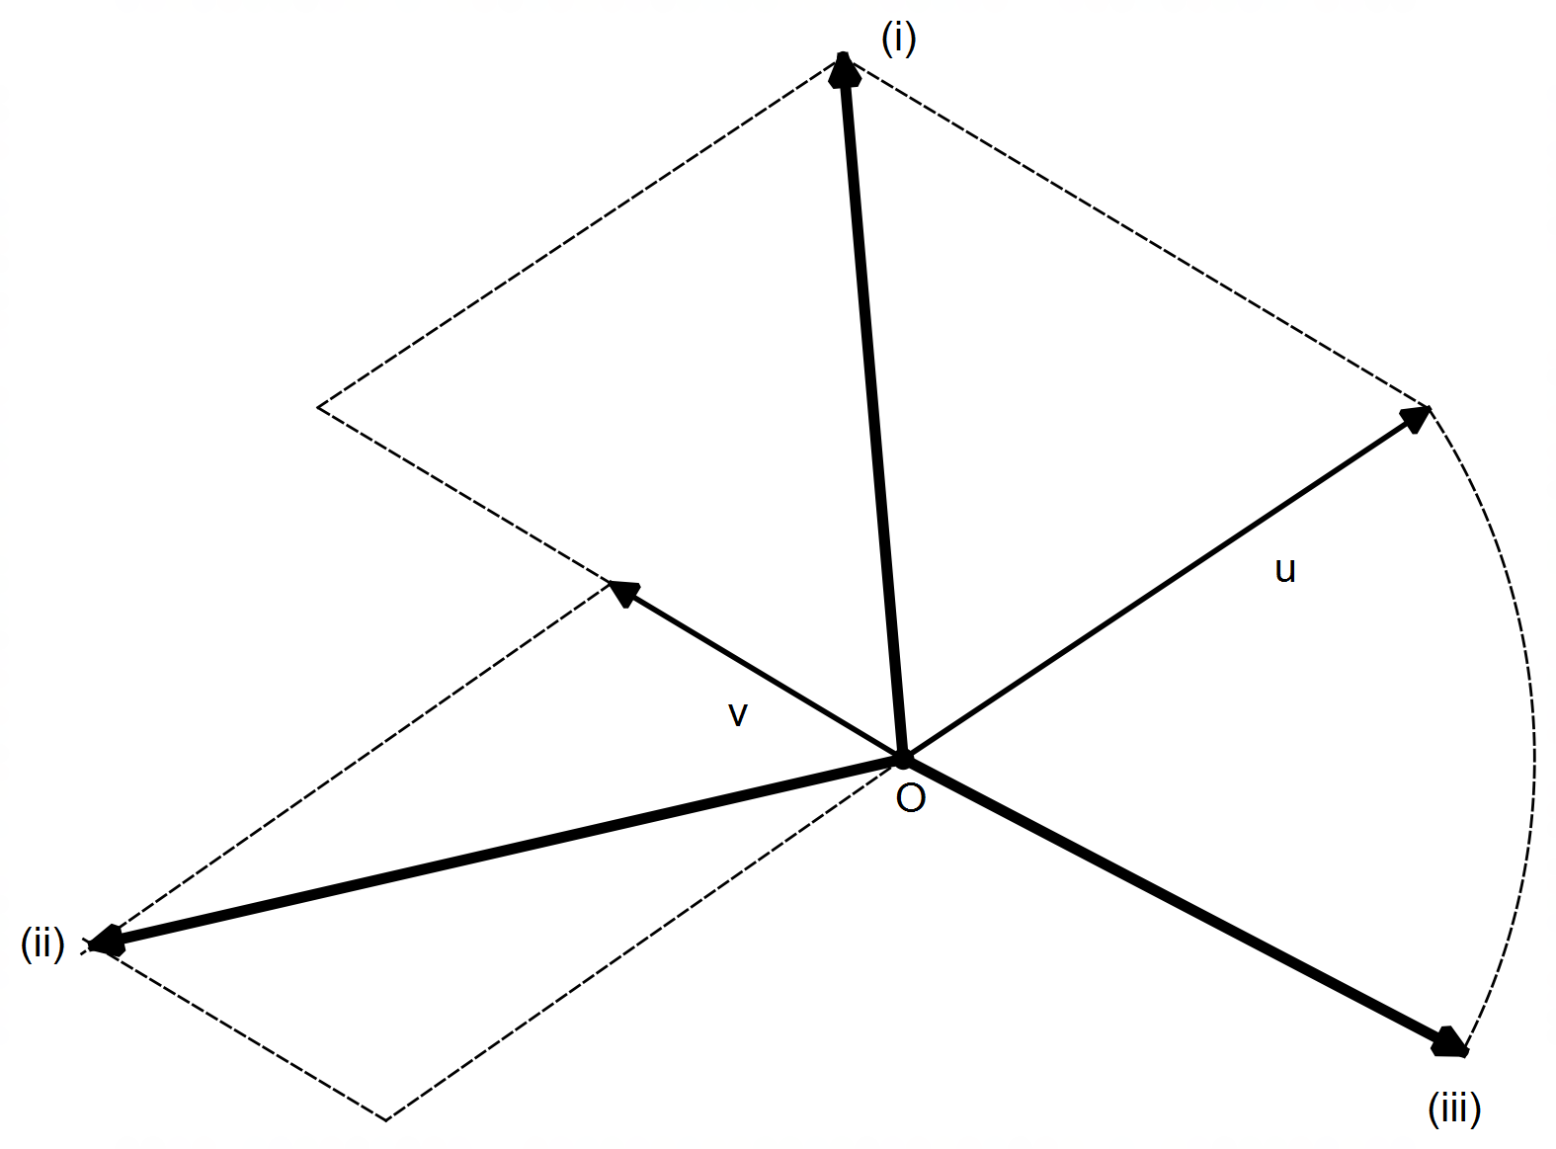

✓ parallelogram with 2v and u as sides

✓ parallelogram with v and –u as sides

✓ vector u in the direction of –v with magnitude |u|

[6]

2. (a) (i) ✓

✓

(ii) ✓

✓

(iii) $\vec{PQ}=\left(\begin{matrix}1 \\ α+5\end{matrix}\right)$

since the *x*–coordinate is already 1 unit in length, then

the y–coordinate must be zero. ✓

✓

(iv) PQ as base ⇒ |OP| = |OQ|

✓

✓

2. (b) (i) Solving simultaneously (any method, elimination shown below):

✓✓

similarly (or by substitution):

✓✓

(ii)

✓✓ [14]

3. (a) (i) ✓

✓

(ii) ✓

✓

(b) RHS ✓

✓

LHS [6]

4. (a) If , then . ✓

It is NOT always true because it does not work for negatives. ✓

e.g. $m=-2<1 → m^{2}=4>m ∴$ false ✓

The converse is always true for ✓

(b) If the parallelogram is not a rectangle, then it does not have congruent diagonals. ✓

Yes it is always true as only squares and rectangles have congruent diagonals. ✓

(c) For all rational numbers ✓, there exists two integer numbers $a$ and ✓

such that $p$ is the quotient of and . [8]

5. (a) (i) ✓

(ii)

✓

✓

(b) (i) $x=3$ since ✓

(ii) $x=7$ since ✓

(iii) $x=8$ since ✓

(c)

✓

✓✓

(d) (i) ✓

(ii) ✓

(iii) ✓

✓ [13]

6. (a) ✓

✓

✓

(b) given

✓

since $a$ and $b$ are non–parallel, then:

✓

✓ [6]

***Calculator−assumed Solutions***

7. (a) ABC collinear ⇒ AB // BC

✓✓

Since $k$ is unique, then AB // BC and hence ABC collinear. ✓

(b) and ✓

✓ [5]

8. (a) ∠PFO = 35° ✓

Because ΔOFP is isosceles since |OP| = |OF| = radii ✓

(b) ∠FEP = 55° ✓

Since ∠FOP = 110° from ΔOFP, and the angle at the centre

is double the size of the angle at the edge. ✓

(c) ∠PQF = ∠FEP = 55° ✓

Angles at the circumference within the same segment

are congruent. ✓

(d) ∠CFP = ∠FEP = 55° ✓

The alternate segment theorem ✓

(e) |GC| = |CF| = 11 – |FB| = 11 – 8 = 3 cm ✓

Tangents to a circle from the same external point

are congruent. ✓

(f) |AM|×(|AM| + 2×radius) = |AH|2

|AM|×(|AM|+8) = 52 ✓

|AM|2+8|AM| – 25 = 0

CAS ⇒ |AM| = ✓

|AM| = cm only solution ✓ [13]

9. (a) (i) Divisible by 3 and 5 = divisible by 15

100 ÷ 15 = 6.6 ⇒ only 6 elements are divisible by 15 ✓

Therefore, assuming every other element is chosen

instead of those 6, we need 100 – 6 +1 = 95 elements ✓

(ii) Divisible by 3 = 100 ÷ 3 = 33.3 ⇒ 33 elements

Divisible by 5 = 100 ÷ 5 = 20 elements ✓

Divisible by 3 or 5 = 33 + 20 – 6 = 47 elements ✓

Assuming the other 53 elements are chosen first,

then 53 + 1 = 54 elements must be chosen ✓

(b) Assuming the highest numbers are chosen first:

100 + 99 + 98 + … + 91 + 90 = 955 ✓

If 89 is chosen next then the sum exceeds 1000. ✓

Therefore, a maximum of 11 elements must be chosen. ✓ [8]

10. (a) ✓

14 334 ✓ = 7 531 + 9 885 – $n\left(M∩C\right)$

$∴n\left(M∩C\right)$ = 3 082 households ✓

(b)

✓

7 531 + 9 885 + 4 977 – 3 082 – 2 252 – 4 310 + 1 724

= 14 473 that have all three ✓

Therefore, 16 366 – 14 473 = 1 893 households have neither ✓ [6]

11. (a) (i) ✓

(ii) ✓✓

(iii) ✓✓

(b) II and III ✓✓

(c)

✓

✓

✓

11. (d) LHS ✓

✓

✓

RHS ✓ [14]

12. (a)

Hovering speed ✓✓

(b) (i)

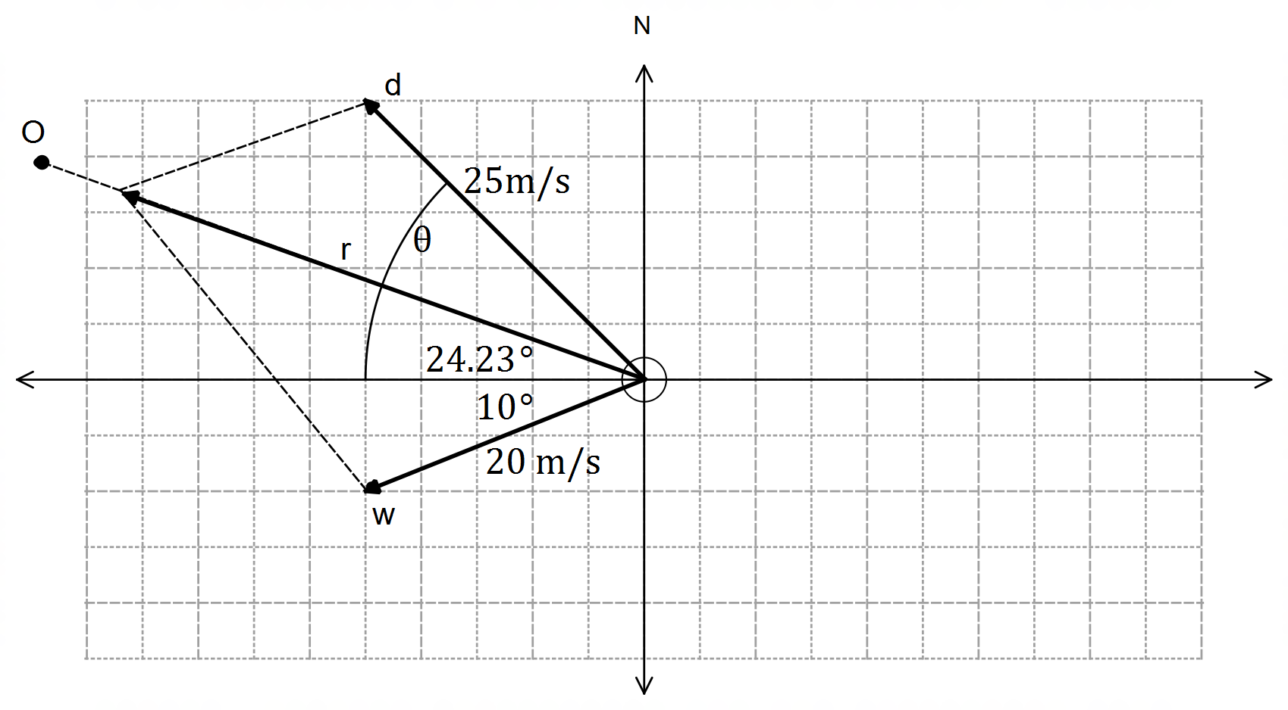

✓ wind vector with correct x-axis

angle

✓ drone vector as a side of

parallelogram and angle θ

✓ resultant vector pointing towards O,

and diagonal of parallelogram

(ii) ✓✓✓

(iii)

✓✓

CAS $→ r=38.8621$ m/s OR $r=-5.7897$ m/s ✓

OR ✓

seconds ✓

bearing ✓ [14]

13. (a) ✓

✓

Since $473.8N<500N$ the machinery is not moving upwards ✓

(b) No horizontal component needed ⇒

✓

✓

(c) ✓

✓ [7]

14. (a) (i) Let with $n=2k+1=$ odd ✓

Then

✓

✓

Since 2 is a factor, then $n^{2}+1$ is divisible by 2, and

hence the conjecture is true ✓

(ii) Contrapositive statement:

“if $n^{2}+1$ is odd, then $n$ is even.” ✓

Let

✓

✓

Since the contrapositive statement is true $∀ n∈N$,

then the original conjecture is true ✓

(b) A ⇒ B:

If the quadrilateral has two diagonals that intersect at right angles,

then the quadrilateral is a rhombus, which implies it does have

two pairs of parallel sides.

$∴$ A ⇒ B is true ✓

B ⇒ A:

If the quadrilateral has two pairs of parallel sides then it is a parallelogram,

which does not necessarily imply it is a rhombus, and therefore it does not necessarily have diagonals that intersect at right angles.

$∴$ B ⇒ A is false ✓

Therefore, A ⇔ B is a false statement. ✓

(c) Assume that $n$ is odd and $n^{2}$ is even. ✓

Then

✓

✓

Since $n^{2}$ is both even and odd simultaneously, this is a contradiction ✓

and therefore the original conjecture must be true $∀ n∈N, n$ even. [15]

15. (a) (i) ✓

(ii) $\vec{AB}∙\vec{AB}={\left|OA\right|}^{2}+{\left|OB\right|}^{2}-2\left|OA\right|\left|OB\right|\cos{θ}$

LHS ✓

✓

✓

✓

as required

(b) (i)

✓

✓

Since $\cos{θ}<0$ ⇒ $θ$ is obtuse ✓

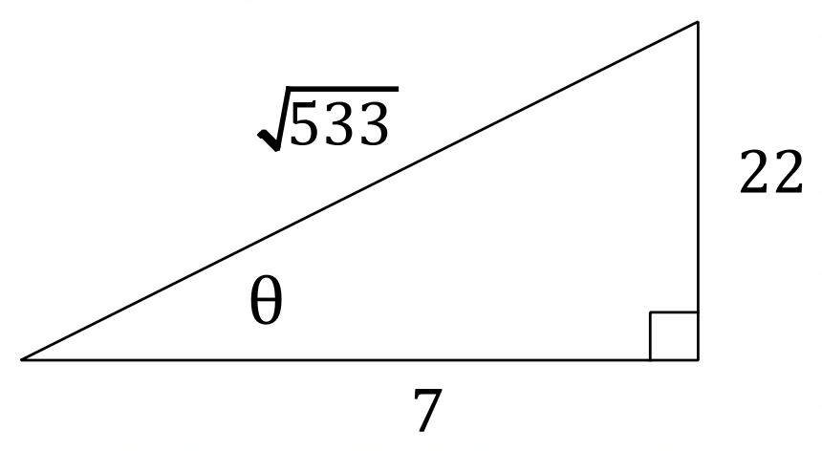

(ii) ⇒ ✓

area ΔOAB

units2 ✓ [10]

16. P, Q, R and S are the midpoints of their respective sides:

✓

Therefore:

✓

// ✓

✓

// ✓

Since $\vec{PQ}$// $\vec{SR}$ and $\vec{PS}$// $\vec{QR}$ ⇒ $PQRS$ is a parallelogram [5]